**Task 2: Prepare Automation Test Script and also perform the test execution**

I have created two Classes here :-

1. ReusableMethods - for creation of page Objects and for calling repeatable methods .
2. TestCases - TestNG class for implementing TestNG framework .

## ReusableMethods Class–

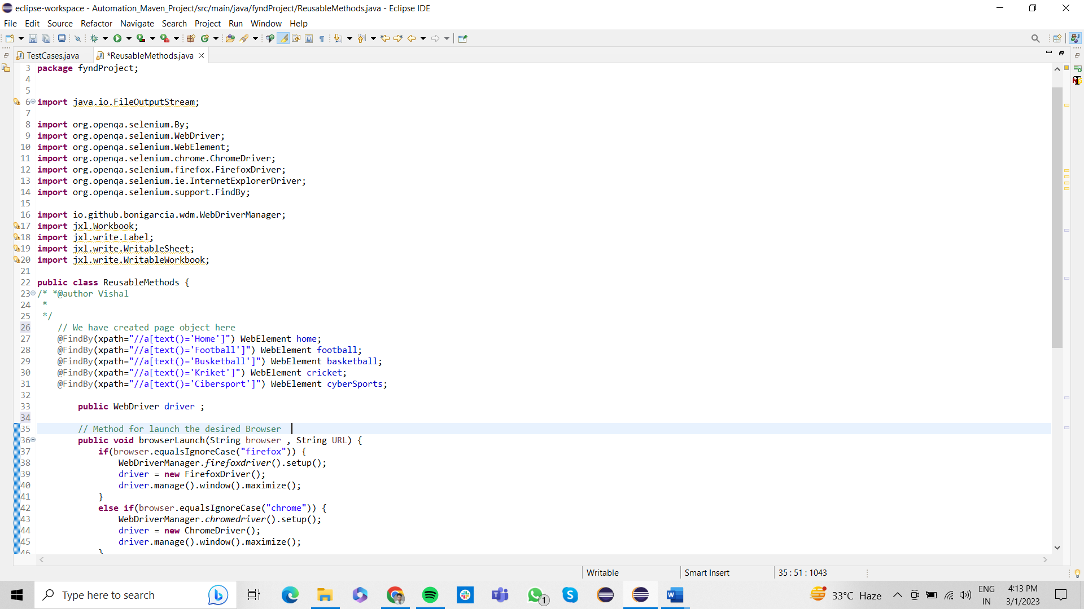

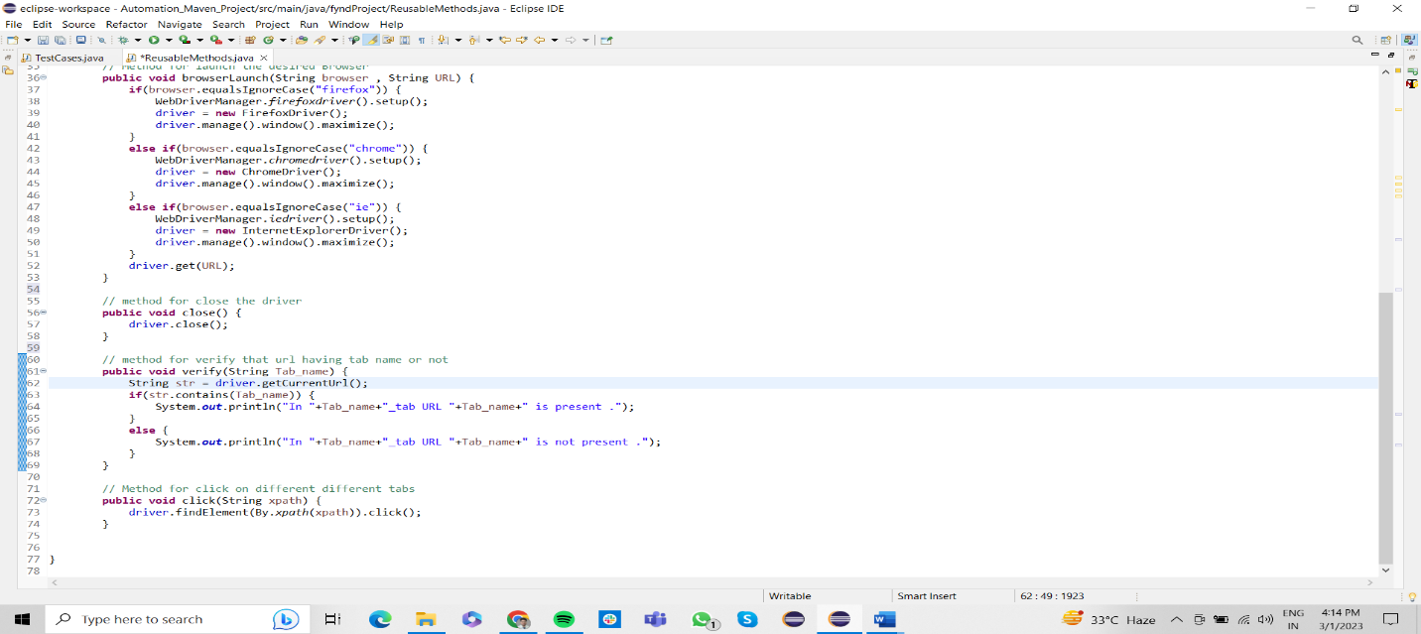

## TestCases Class-

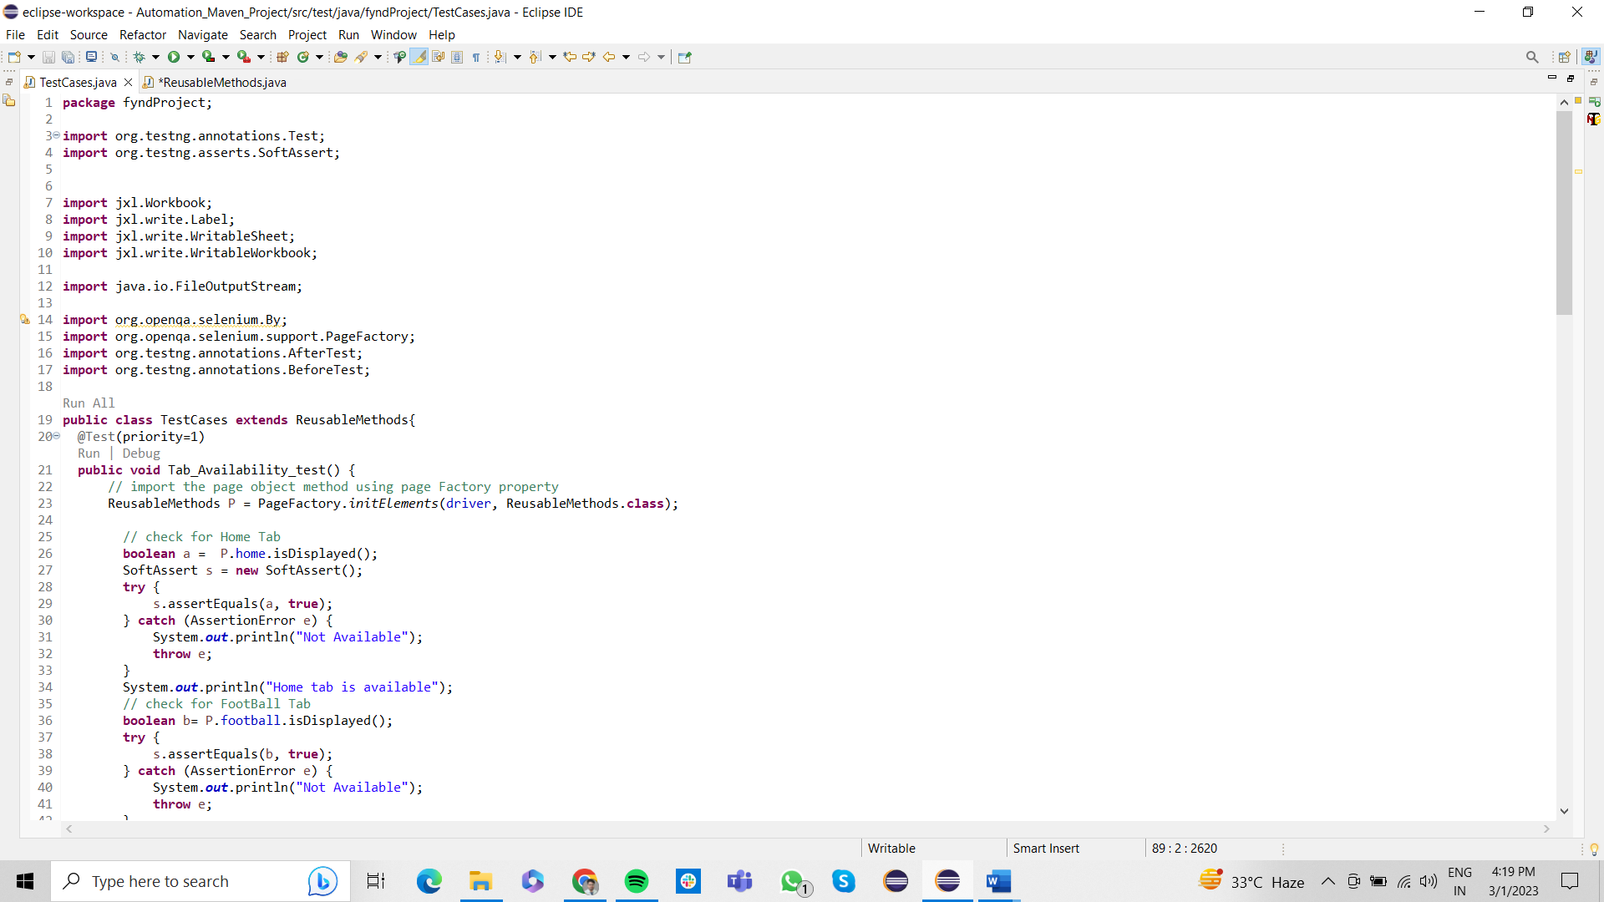

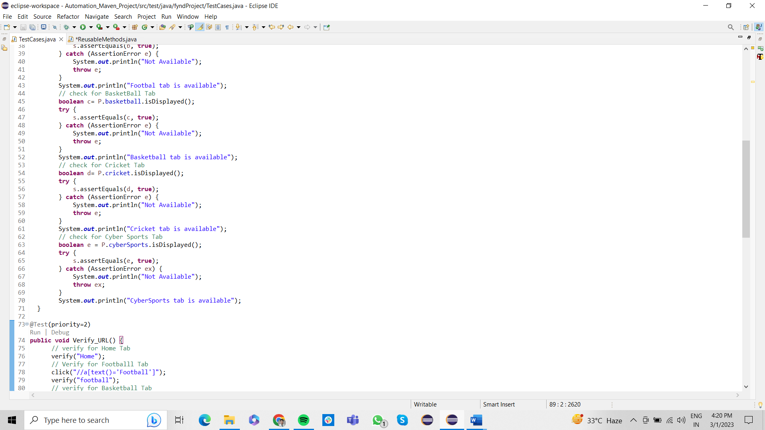

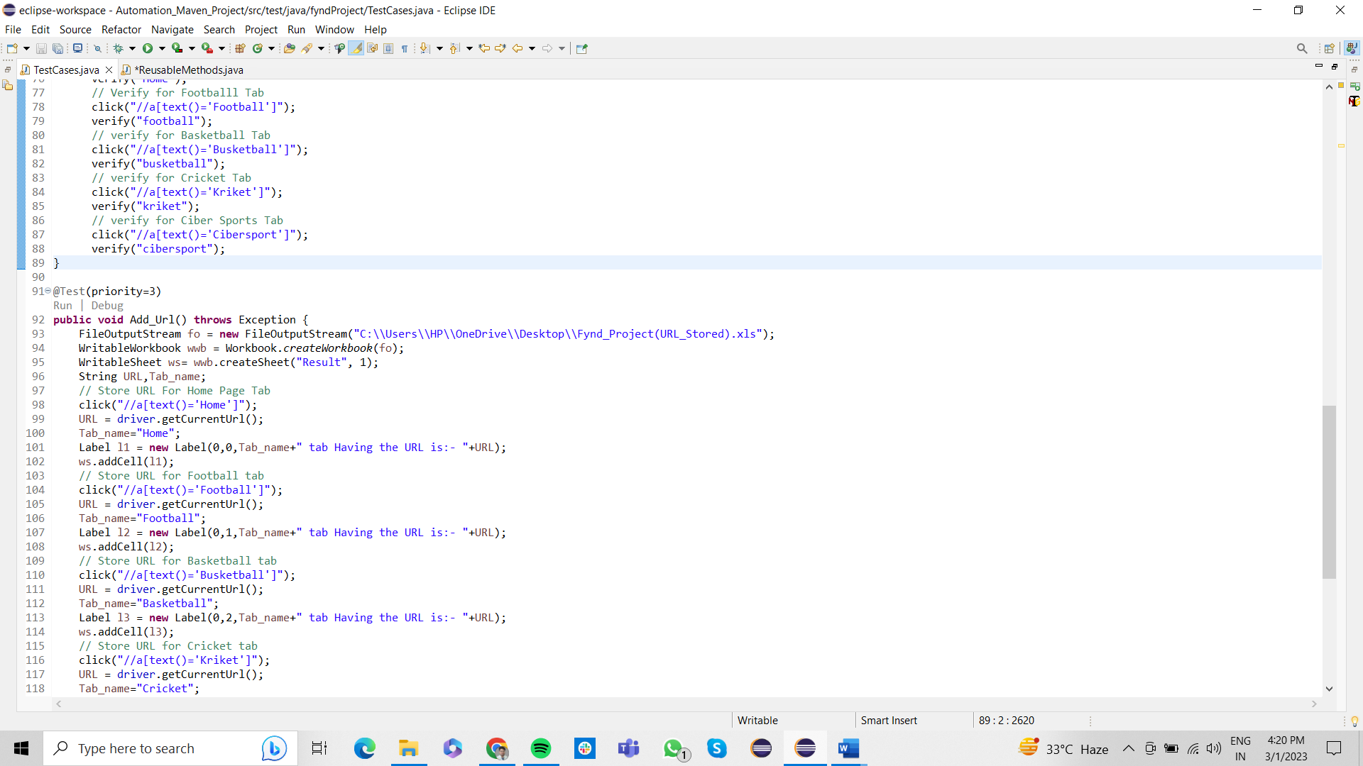

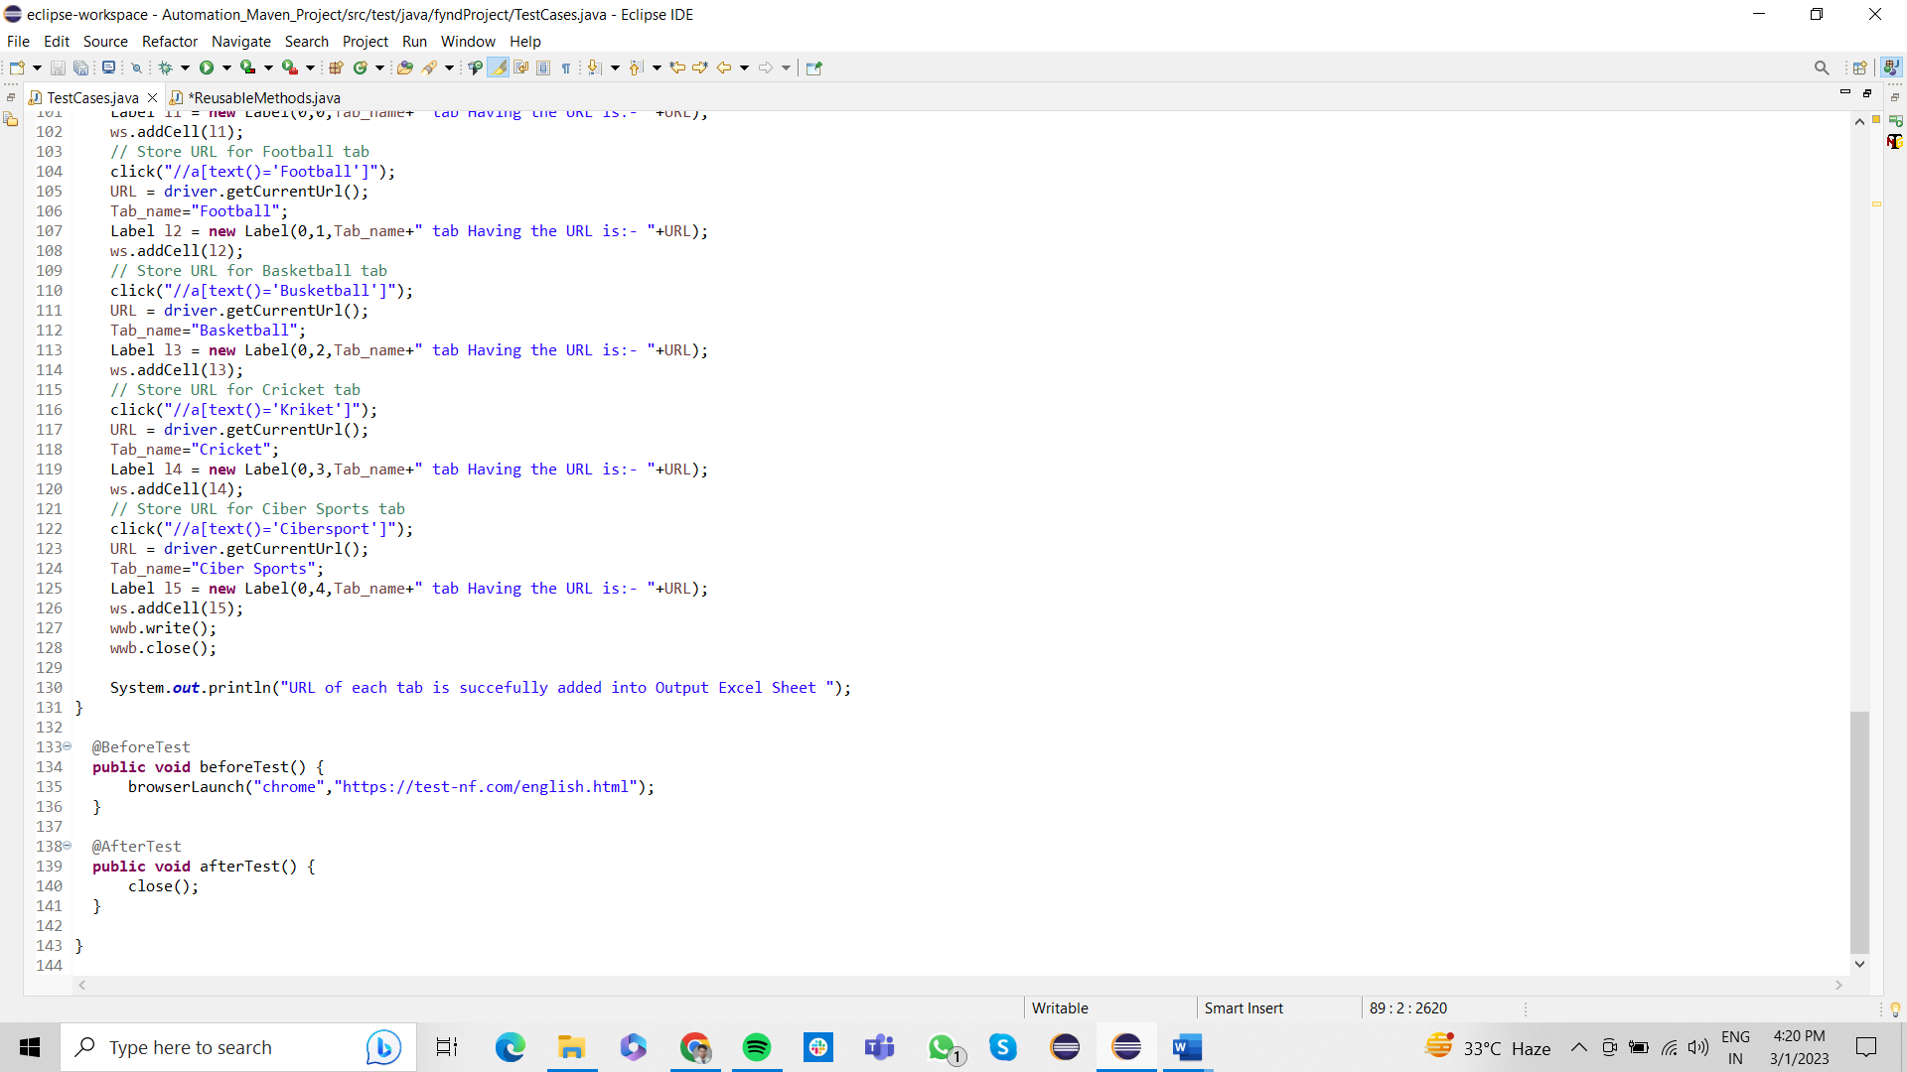

## Output –

